USER INTERFACE AND DESIGN
EXPERIMENT-3
NAME : ABINASH G ROLL NO:240701007

1.COMMAND LINE INTERFACE:
PYTHON CODE:
import os
import sys
def rename_file(old_name, new_name):
if not os.path.exists(old_name):
print(f"Error: '{old_name}' not found.")
return

if os.path.exists(new_name):
print(f"Error: '{new_name}' already exists.")
return

try:
os.rename(old_name, new_name)
print(f"Success: File renamed from '{old_name}' to '{new_name}'")
except Exception as e:
print(f"Error: {e}")
if __name__ == "__main__":

if len(sys.argv) != 3:
print("Usage: python CLI.py <old_filename> <new_filename>")
else:
rename_file(sys.argv[1], sys.argv[2])

OUTPUT:
2.GRAPHICAL USER INTERFACE:
PYTHON CODE:
import tkinter as tk
from tkinter import messagebox
import os

def rename_file():
old_name = old_entry.get().strip()
new_name = new_entry.get().strip()

if not old_name or not new_name:
messagebox.showwarning("Warning", "Please enter both filenames")
return

if not os.path.exists(old_name):
messagebox.showerror("Error", f"File '{old_name}' not found")
return

try:
os.rename(old_name, new_name)
messagebox.showinfo("Success", f"File renamed from '{old_name}' to '{new_name}'")
except Exception as e:
messagebox.showerror("Error", str(e))

root = tk.Tk()
root.title("File Renamer")
root.geometry("400x150")
root.resizable(False, False)

tk.Label(root, text="Old Filename:").grid(row=0, column=0, padx=10, pady=5)
tk.Label(root, text="New Filename:").grid(row=1, column=0, padx=10, pady=5)

old_entry = tk.Entry(root, width=40)
old_entry.grid(row=0, column=1, padx=10, pady=5)

new_entry = tk.Entry(root, width=40)
new_entry.grid(row=1, column=1, padx=10, pady=5)

tk.Button(root, text="Rename File", bg="green", fg="white",
command=rename_file).grid(row=2, column=0, columnspan=2, pady=10)

root.mainloop()

OUTPUT:

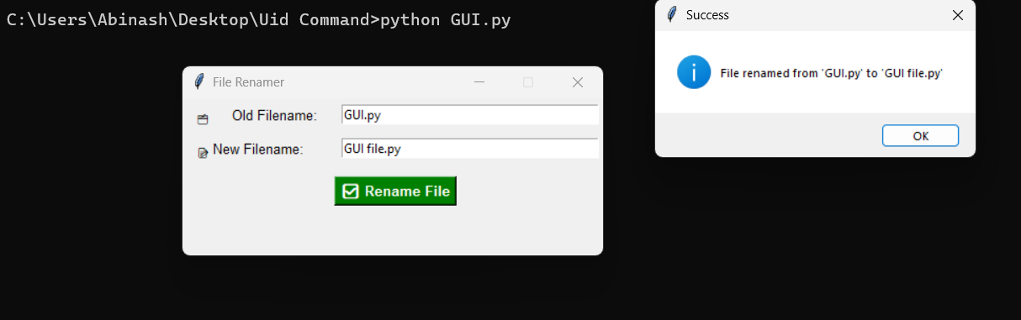

3.VOICE USER INTERFACE:
PYTHON CODE:
import speech_recognition as sr
import os

def rename_file_from_voice(command):
words = command.lower().split()

if "rename" in words and "to" in words:
old_name = words[words.index("rename") + 1]
new_name = words[words.index("to") + 1]

if not os.path.exists(old_name):
print(f"Error: File '{old_name}' not found.")
return

os.rename(old_name, new_name)
print(f"File renamed from '{old_name}' to '{new_name}'")
else:
print("Invalid command format.")

def listen_for_command():
r = sr.Recognizer()
with sr.Microphone() as source:
print("Listening for command to rename a file...")
r.adjust_for_ambient_noise(source)
audio = r.listen(source)

try:
command = r.recognize_google(audio)
print("Command received:", command)
rename_file_from_voice(command)
except sr.UnknownValueError:
print("Could not understand the command.")
except sr.RequestError as e:
print("Request error:", e)

if __name__ == "__main__":
listen_for_command()

OUTPUT:

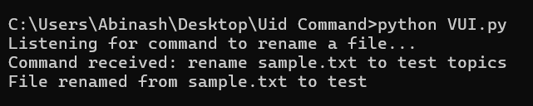

4.USER SATISFACTION COMPARISON:
PYTHON CODE:
def survey():
print("Rate your satisfaction with the following interfaces (1-5):")

try:
cli = int(input("CLI (1-5): "))
gui = int(input("GUI (1-5): "))
vui = int(input("VUI (1-5): "))

if not (1 <= cli <= 5 and 1 <= gui <= 5 and 1 <= vui <= 5):
print("Please enter values between 1 and 5 only.")
return

print("\nYour satisfaction ratings:")
print(f"CLI: {cli}")
print(f"GUI: {gui}")
print(f"VUI: {vui}")

avg = (cli + gui + vui) / 3
print(f"\nAverage Satisfaction Score: {avg:.2f}")

except ValueError:
print("Invalid input! Enter numbers only.")

if __name__ == "__main__":
survey()
OUTPUT:

